

Title:
Web Application Security Assessment and Hardening

Name:
Muhammad Yaseen
Intern ID:
DHC-355

Week 1: Security Assessment Report

1. Introduction
The objective of this task is to perform a basic security assessment on a web-based application in order to identify common vulnerabilities. For this purpose, OWASP Juice Shop, a deliberately vulnerable web application, was selected. The assessment focuses on understanding the application, performing basic vulnerability tests using simple tools, and documenting the findings for further improvement.

2. Application Setup and Exploration
OWASP Juice Shop was installed locally using Node.js and npm. After installation, the application was launched successfully and accessed through a web browser at http://localhost:3000. The application provides core user management functionalities such as login, registration, and user interaction features.
During exploration, the main areas reviewed included the login page, registration functionality, product search feature, and user account-related components. This initial exploration helped in identifying areas where user input is accepted and processed by the application.
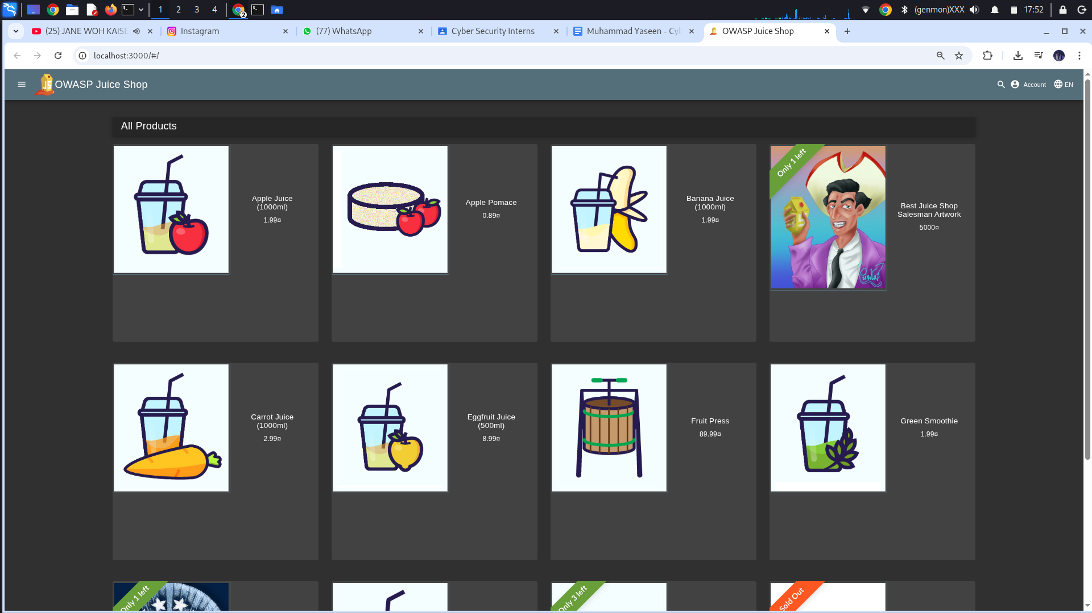
Screenshot 1: OWASP Juice Shop running on http://localhost:3000 showing the home page.

3. Vulnerability Assessment Methodology
The vulnerability assessment was conducted using a combination of manual testing and automated scanning tools. The goal was to identify common web application vulnerabilities such as Cross-Site Scripting (XSS), SQL Injection, weak password handling, and basic security misconfigurations.
The following tools and techniques were used:
- Browser Developer Tools for manual input testing
- OWASP ZAP for automated vulnerability scanning
- Manual payload testing for SQL injection attempts

4. Cross-Site Scripting (XSS) Testing
To test for Cross-Site Scripting vulnerabilities, user input fields within the application were targeted, including the search and feedback input areas. A basic JavaScript payload was injected to determine whether user input was properly sanitized.
Payload used:
<img src=x onerror=alert('XSS')>

Upon submitting the payload, a JavaScript alert was triggered, confirming the presence of an XSS vulnerability. This indicates that user input is not sufficiently sanitized or encoded before being rendered in the browser.
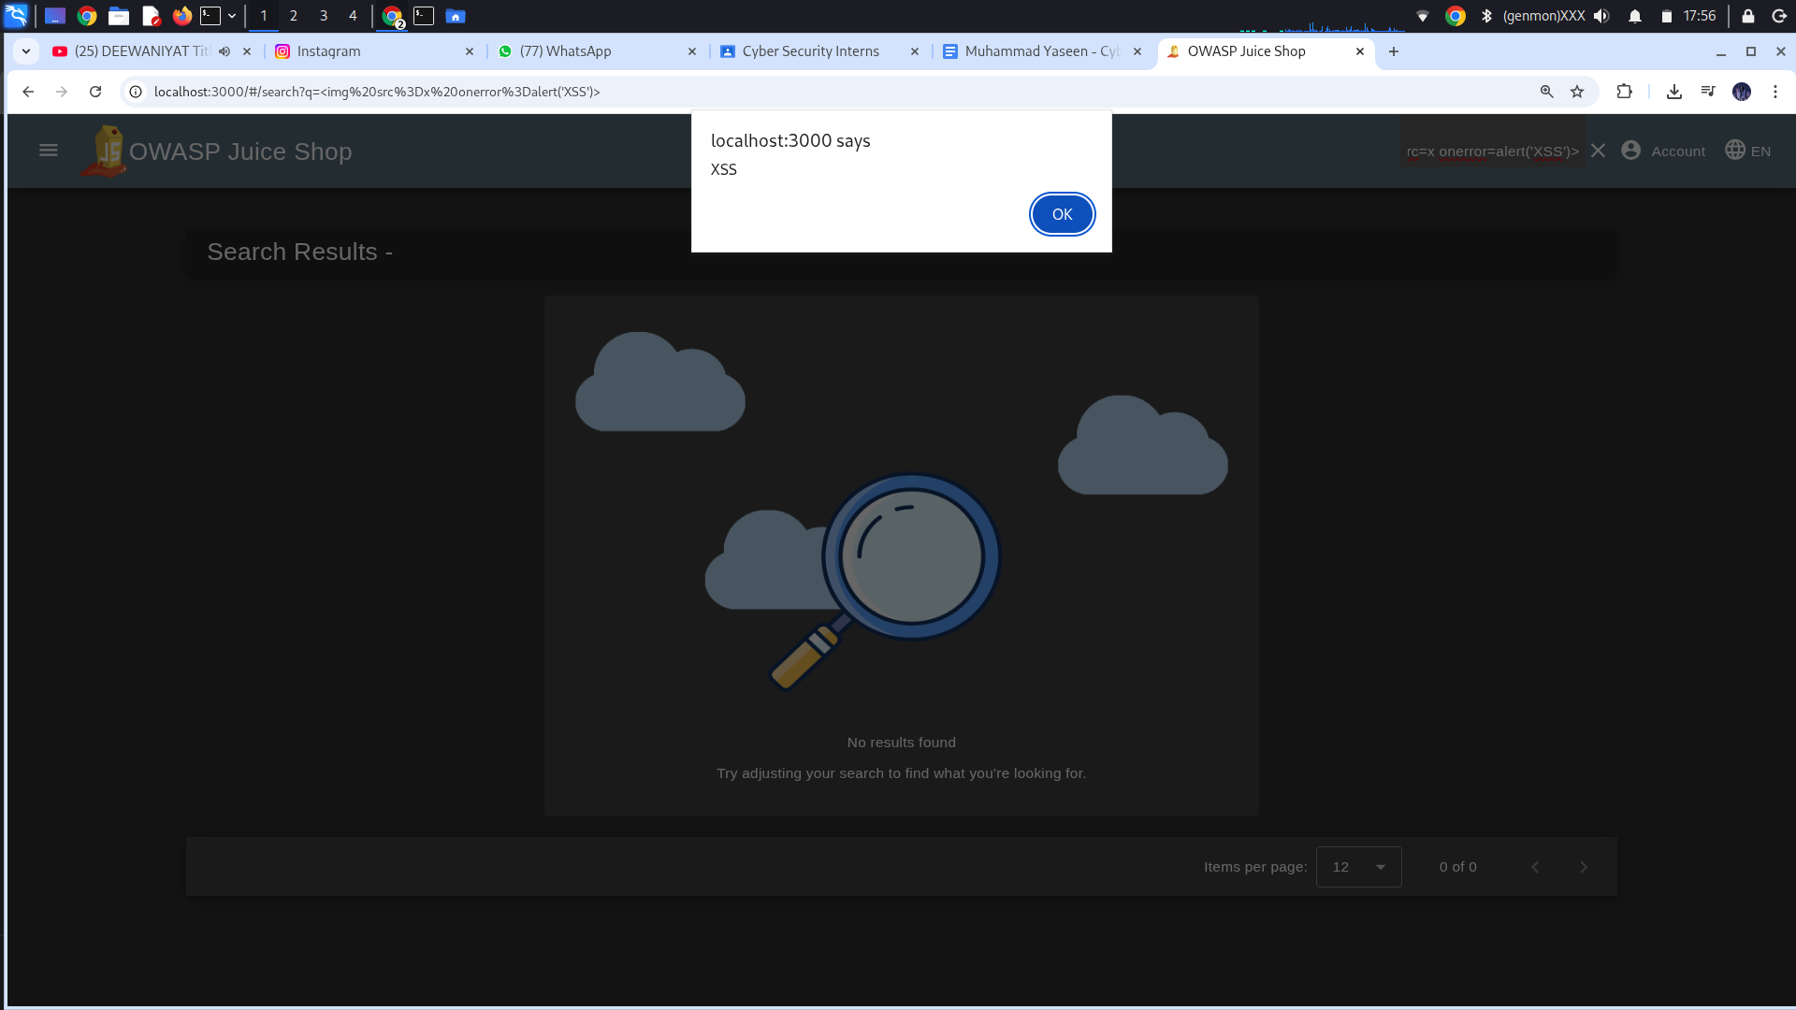
Screenshot 2: Alert popup displaying “XSS” after injecting the script payload.

5. SQL Injection Testing
Basic SQL Injection testing was performed on the login functionality of the application. The test aimed to evaluate whether the authentication mechanism properly validates and sanitizes user inputs before processing database queries.
Test credentials used:
Email: admin' OR '1'='1
Password: admin' OR '1'='1

The application responded abnormally, indicating insufficient protection against SQL injection attacks. This suggests that user inputs may be directly incorporated into database queries without proper parameterization.
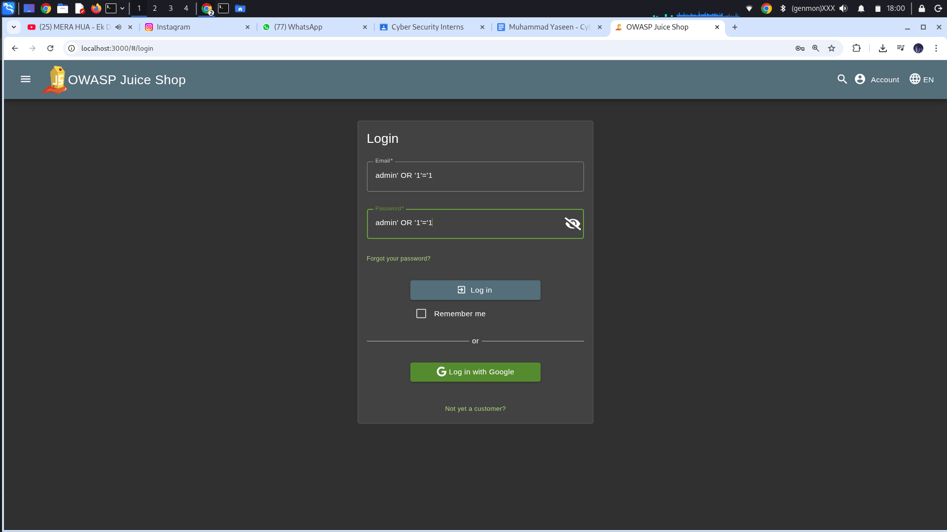
Screenshot 3: Login attempt using SQL injection payload.

6. Automated Vulnerability Scanning (OWASP ZAP)
An automated vulnerability scan was performed using OWASP ZAP to identify additional security weaknesses. The target URL for the scan was set to http://localhost:3000. The scan highlighted multiple alerts related to security misconfigurations, including missing HTTP security headers and insecure cookie attributes.
These findings further confirm the need for implementing proper security controls at both the application and server levels.
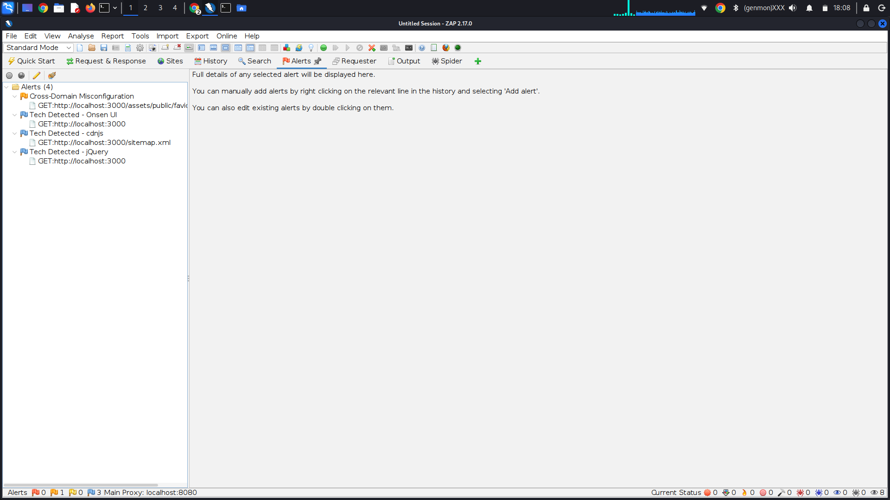
Screenshot 4: OWASP ZAP Alerts tab showing identified vulnerabilities.

7. Findings and Observations
Based on the security assessment, the following vulnerabilities were identified:
- Presence of Cross-Site Scripting (XSS) vulnerabilities due to improper input sanitization
- Weak protection against SQL injection in the authentication mechanism
- Lack of secure password handling practices
- Missing or improperly configured HTTP security headers
- General security misconfigurations increasing attack surface

8. Areas of Improvement
To enhance the overall security posture of the application, the following improvements are recommended:
- Implement server-side input validation and output encoding
- Protect authentication mechanisms using parameterized queries
- Hash and salt user passwords before storage
- Apply security headers using middleware such as Helmet
- Improve error handling and logging mechanisms

9. Conclusion
This initial security assessment highlighted several common web application vulnerabilities within OWASP Juice Shop. The findings demonstrate the importance of implementing basic security best practices to protect against common attack vectors. The identified issues will be addressed in the following phases of the internship by applying appropriate security measures and controls.

Week 2: Implementing Security Measures

2.1 Objective of Week 2
The objective of Week 2 was to address the vulnerabilities identified during the security assessment phase by implementing basic security controls. This phase focused on improving input validation, securing password storage, enhancing authentication mechanisms, and applying security headers to reduce the application’s attack surface.

2.2 Input Validation and Sanitization
One of the key issues identified during Week 1 was the lack of proper input validation, which exposed the application to attacks such as Cross-Site Scripting (XSS) and SQL Injection. To mitigate this risk, server-side input validation and sanitization mechanisms were implemented.
The validator library was used to validate user inputs such as email addresses and to ensure that malformed or malicious data is rejected before further processing. This helps prevent attackers from injecting harmful payloads through user input fields.
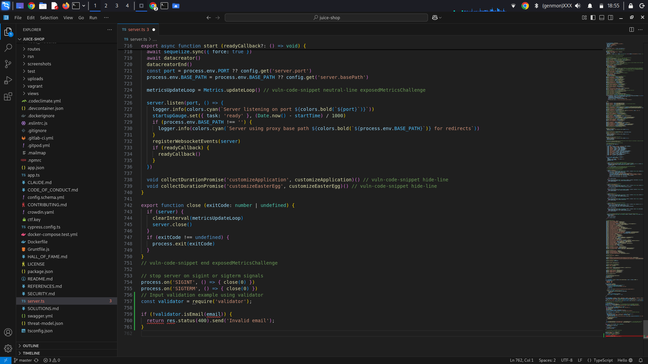
Screenshot 5: Server-side input validation implemented using the validator library.

2.3 Password Hashing and Secure Storage
During Week 1, weak password handling was identified as a major security concern. To address this issue, password hashing was implemented using the bcrypt library. Instead of storing plaintext passwords, user passwords are now hashed before being saved to the database.
Hashing passwords ensures that even if the database is compromised, attackers cannot easily recover user credentials. A salt factor was applied to strengthen the hashing process further.
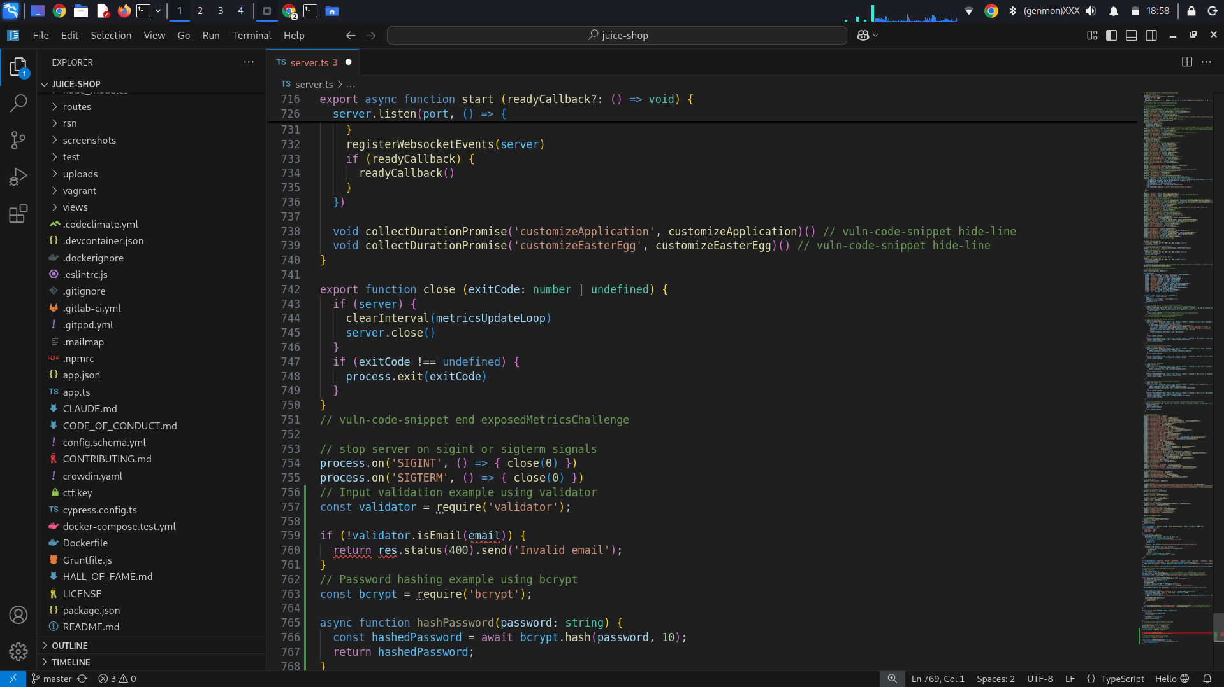
Screenshot 6: Password hashing implemented using bcrypt before database storage.

2.4 Token-Based Authentication (JWT)
To enhance authentication security, token-based authentication was implemented using JSON Web Tokens (JWT). After a successful login, the server generates a signed JWT and returns it to the client. This token is then used to authenticate subsequent requests instead of relying solely on session-based authentication.
JWTs help improve security by reducing the risk of session hijacking and enabling stateless authentication.
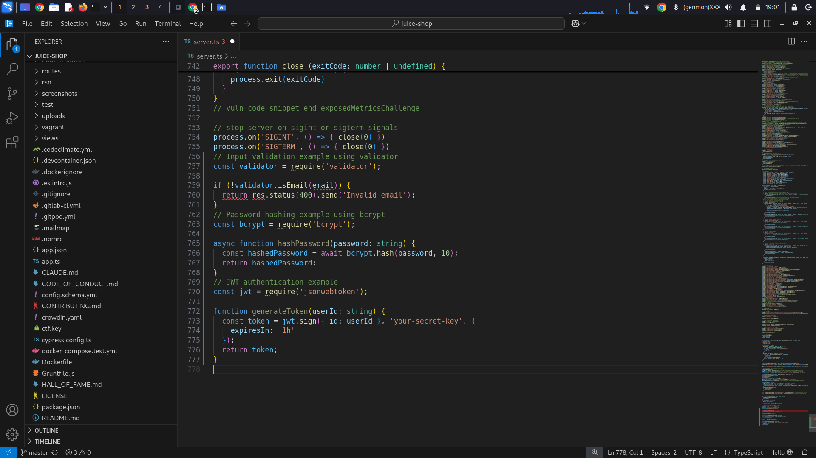
Screenshot 7: JWT token generation implemented for secure authentication.

2.5 Securing HTTP Headers Using Helmet
To protect the application from common web-based attacks, security headers were added using the helmet middleware. Helmet helps secure Express applications by setting HTTP headers such as Content Security Policy (CSP), X-Frame-Options, and X-Content-Type-Options.
This step reduces exposure to attacks such as clickjacking and MIME-type sniffing.
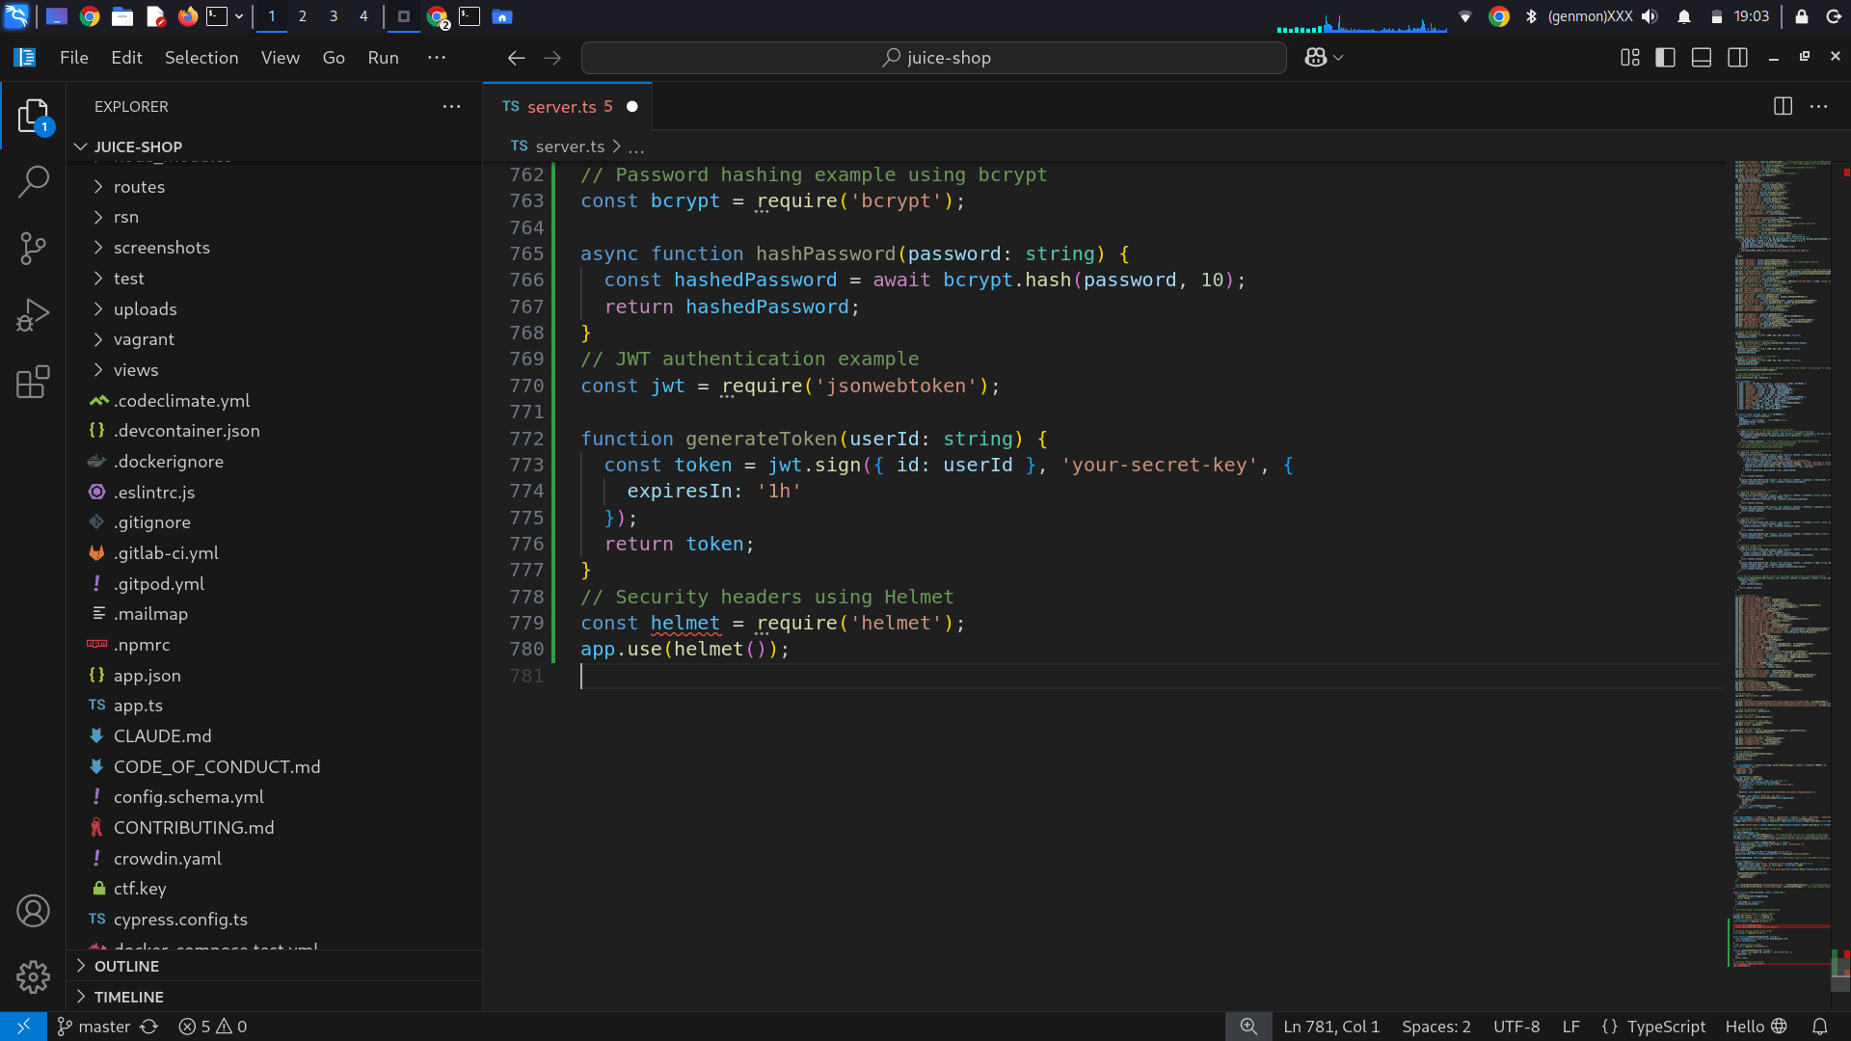
Screenshot 8: Helmet middleware configured to secure HTTP headers.

2.6 Summary of Security Improvements
The following security enhancements were implemented during Week 2:
- Server-side input validation to prevent injection attacks
- Secure password hashing using bcrypt
- Token-based authentication using JWT
- Secure HTTP headers using Helmet middleware
These measures significantly reduce the risk of common web application vulnerabilities and strengthen the overall security posture of the application.

2.7 Conclusion of Week 2
Week 2 focused on transforming identified security weaknesses into actionable improvements. By implementing fundamental security controls, the application is now better protected against common attack vectors such as XSS, SQL Injection, and credential compromise. These improvements provide a stronger foundation for advanced security enhancements in the next phase.

Week 3: Advanced Security and Final Reporting

3.1 Objective of Week 3
The objective of Week 3 was to perform basic penetration testing, enable application logging, and summarize security best practices in the form of a checklist. This phase focuses on validating the effectiveness of previously implemented security measures and ensuring that the application is better prepared for monitoring and incident detection.

5.2 Basic Penetration Testing
To further evaluate the security posture of the application, basic penetration testing techniques were performed. The goal of this step was not exploitation, but rather to simulate common reconnaissance activities that attackers may perform to gather information about the target system.
Basic testing was conducted using command-line tools to identify open ports and running services associated with the application.
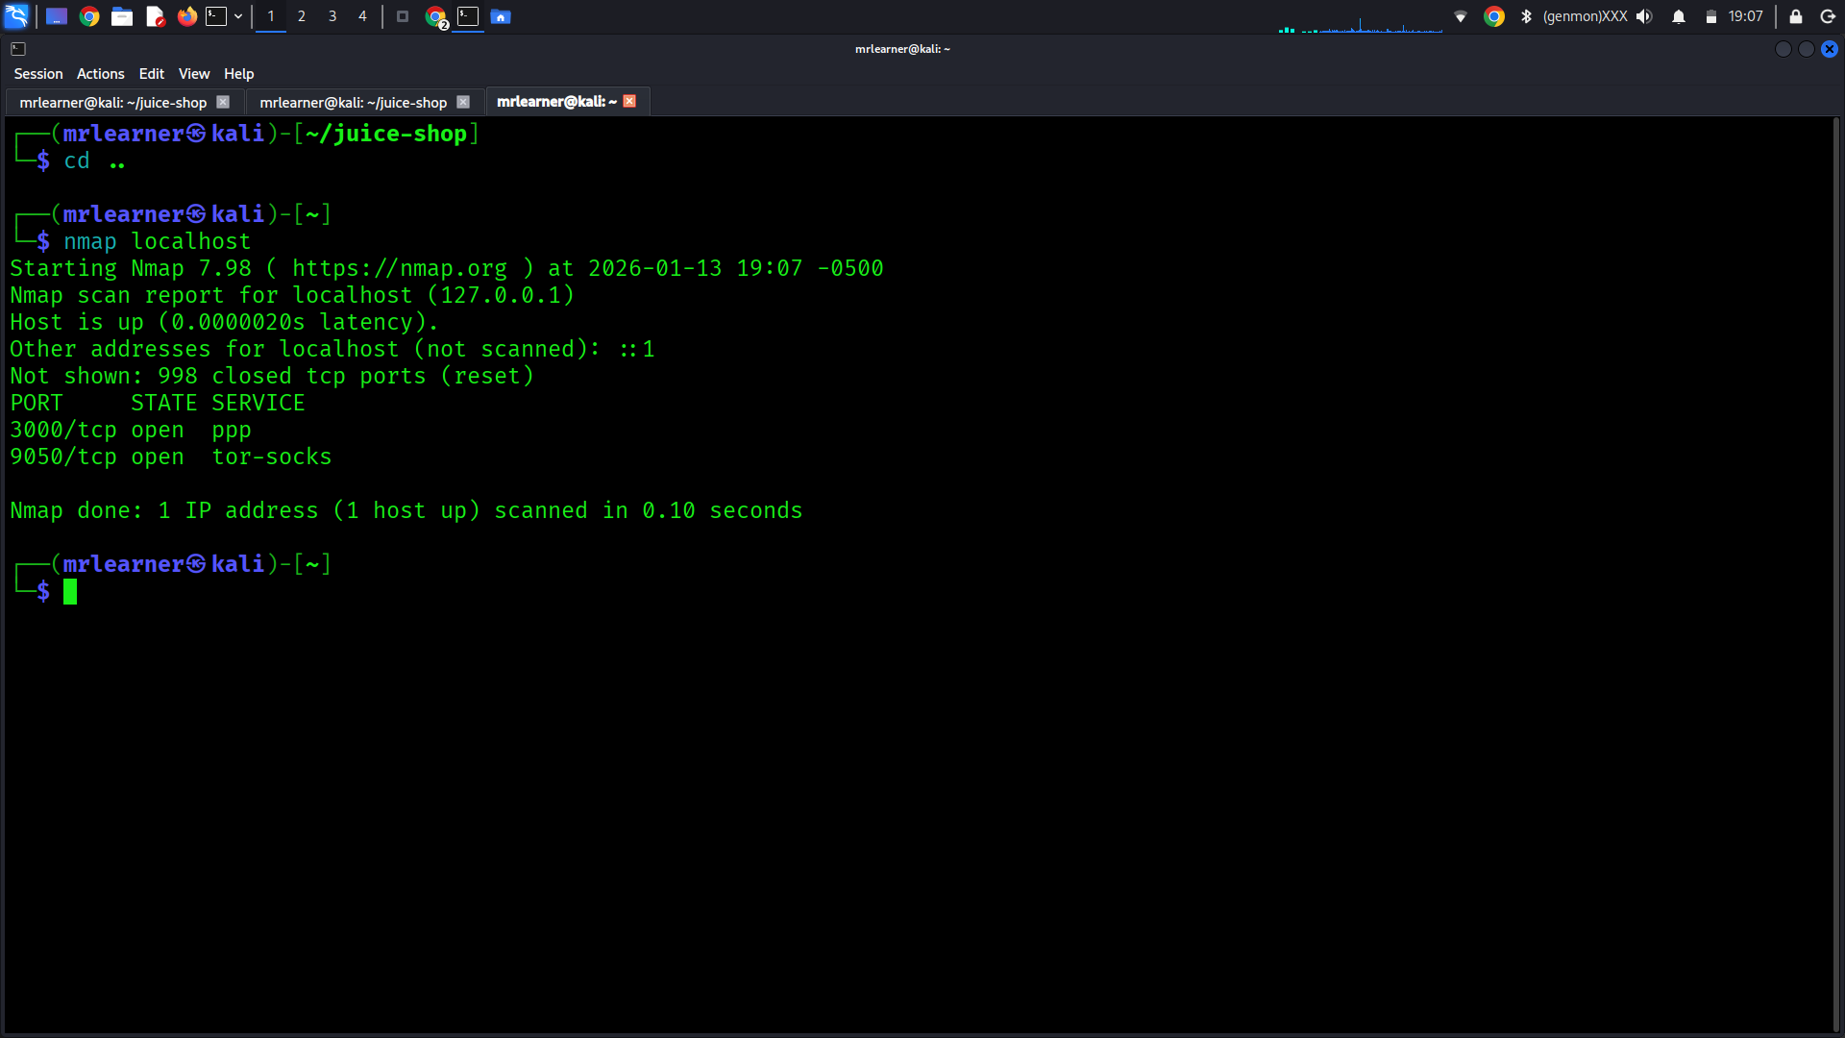
Screenshot 9: Basic reconnaissance performed against the local application.

5.3 Logging and Monitoring Using Winston
To improve monitoring and incident detection, logging was implemented using the winston logging library. Logging plays a critical role in detecting suspicious behavior, debugging issues, and supporting forensic investigations.
A basic logger configuration was added to log important application events such as application startup and security-related actions. Logs were configured to be written both to the console and to a file for persistent storage.
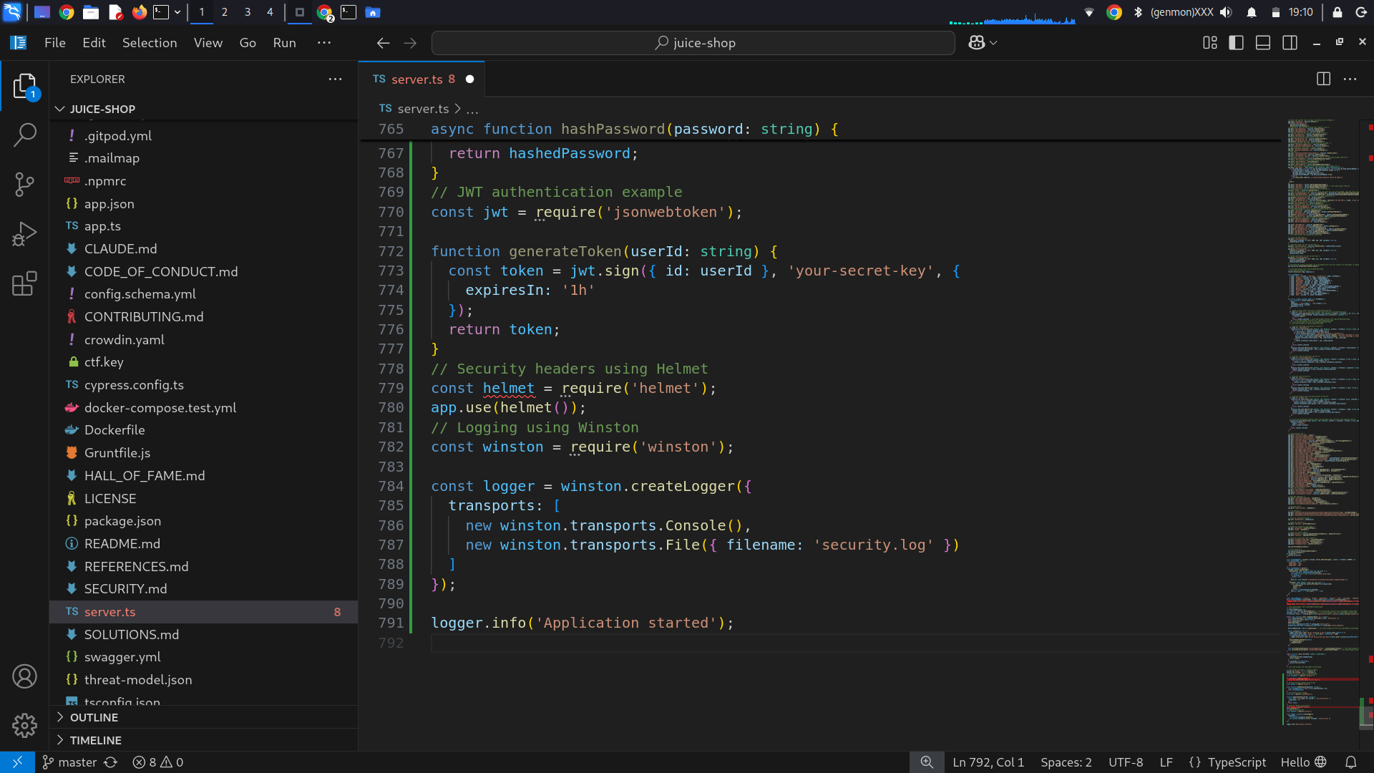
Screenshot 10: Application logging configured using Winston.

5.4 Security Checklist
Based on the assessment and improvements made throughout the internship, the following security checklist summarizes key best practices applied to the application:
- Validate and sanitize all user inputs
- Protect against XSS and SQL Injection attacks
- Hash and salt passwords before storage
- Use token-based authentication mechanisms
- Apply secure HTTP headers
- Enable logging and monitoring
- Minimize information disclosure
- Recommend HTTPS for secure data transmission
This checklist serves as a reference to ensure that fundamental security controls are consistently applied.

5.5 Final Submission Preparation
As part of the final submission, all required deliverables were prepared according to the internship guidelines. These include a detailed report documenting all three weeks of work, a GitHub repository containing the application code and configurations, and a recorded video explaining the tasks performed and the security improvements implemented.
The report consolidates findings, fixes, and best practices into a single document, demonstrating a structured and progressive approach to web application security.

5.6 Conclusion of Week 3
Week 3 focused on validating security improvements, enabling monitoring capabilities, and finalizing documentation. Through basic penetration testing, logging implementation, and the creation of a security checklist, the application’s security posture was further strengthened. This final phase concludes the internship tasks with a comprehensive overview of assessment, remediation, and monitoring activities.

